Github - Jenkins

Step1 : Create Java Project with CalculatorMain and Calculator classes
Step 2:Push Project to GitHub
Step 3:Create Jenkins Job
Step 4: Connect Jenkins to GitHub
In job configuration:
Source Code Management → Git (add repo url and specify branch)

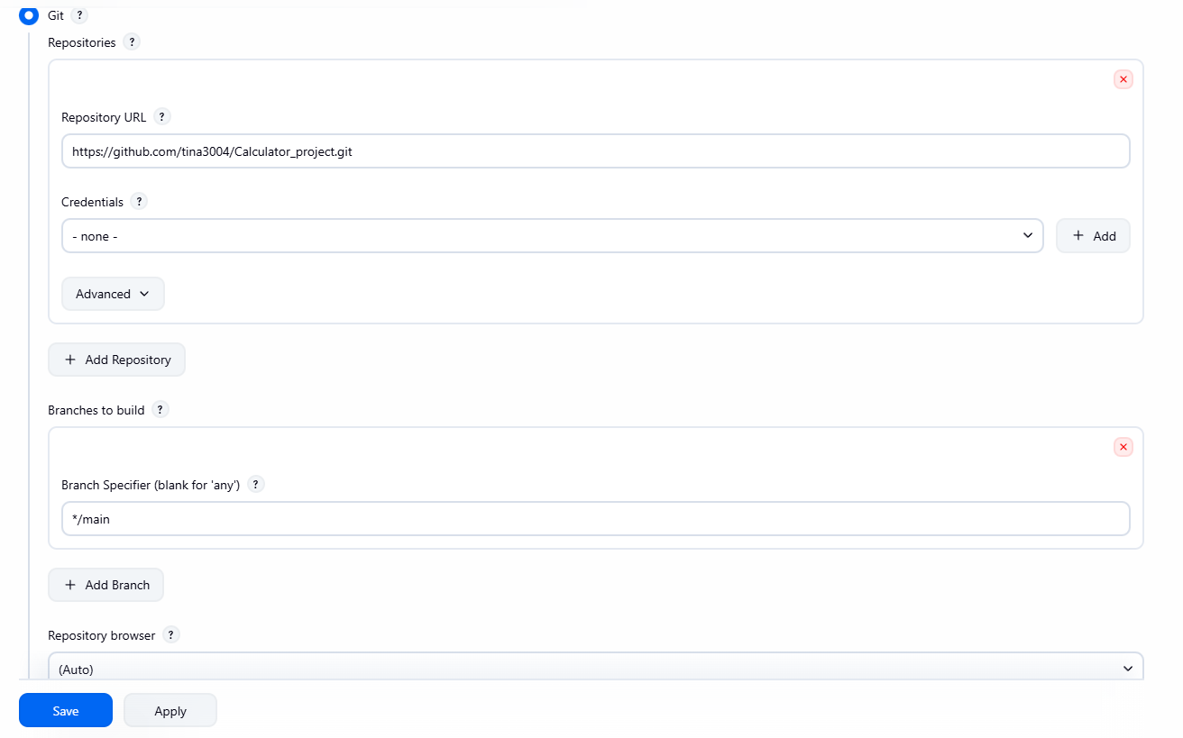
Step 5: Add build trigger
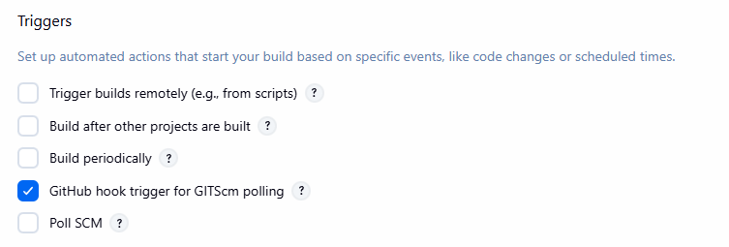
Step 6: Add Build Steps
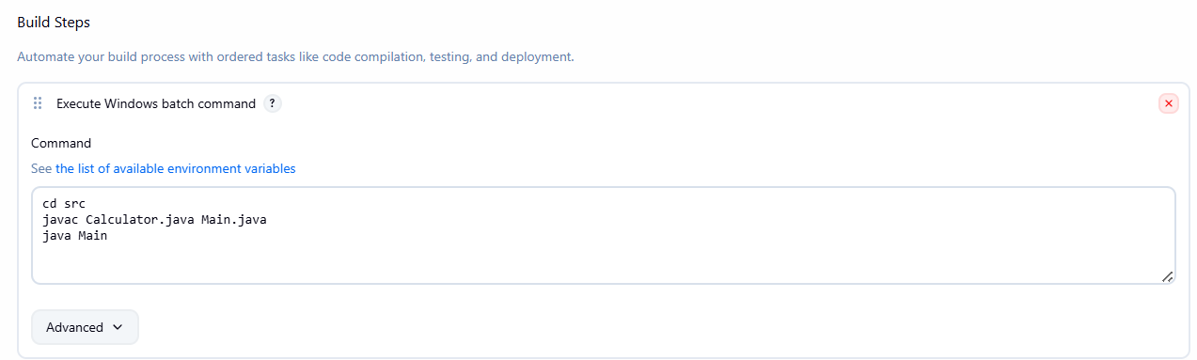

Step 7: Configure ngrok to make localhost public
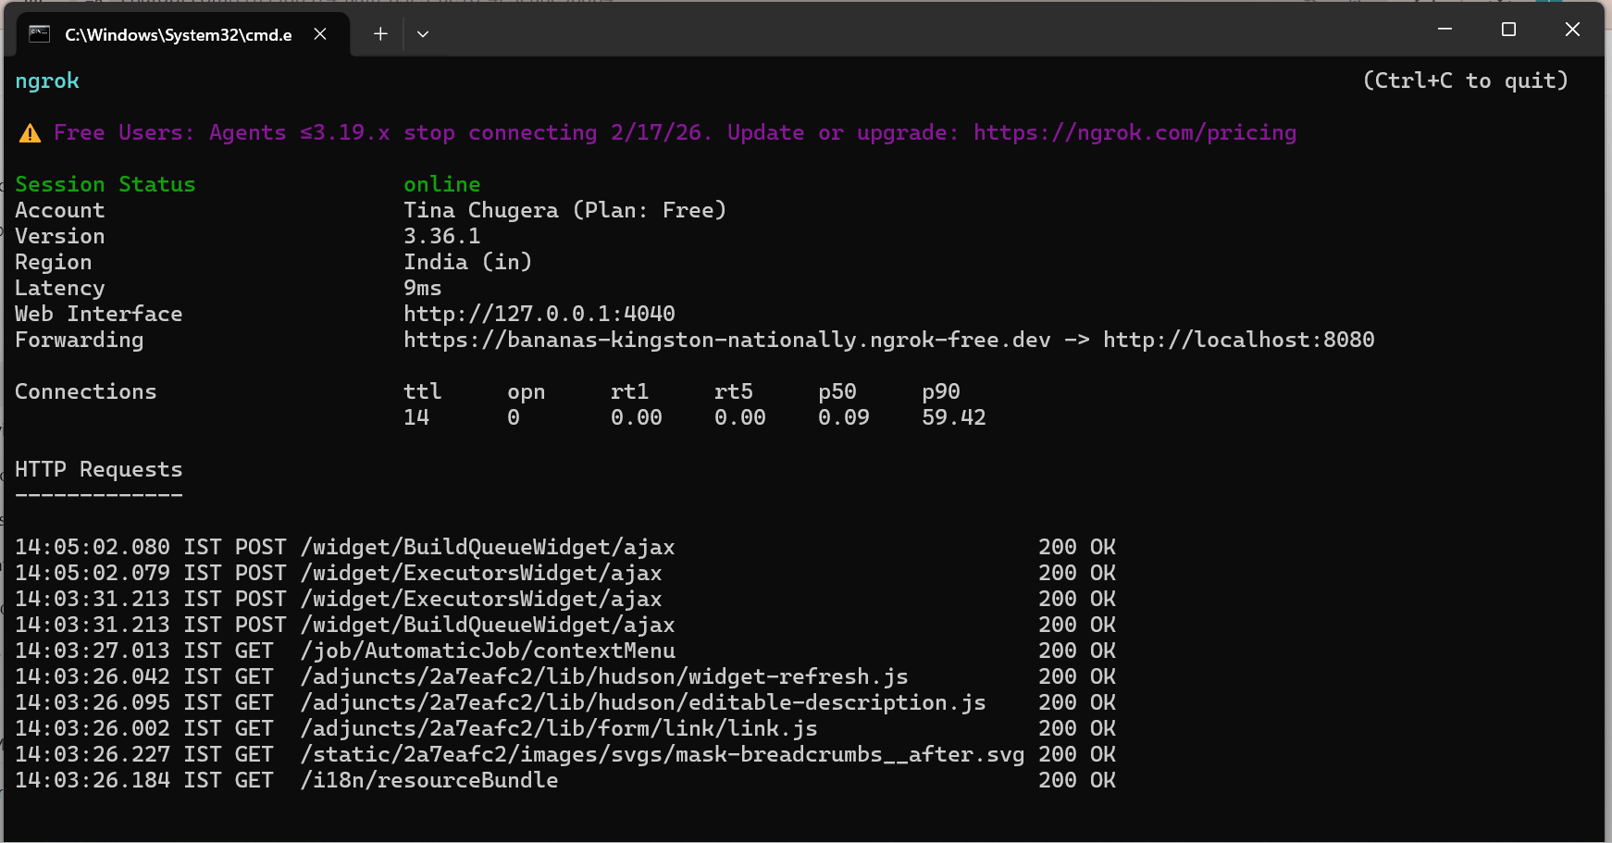
https://bananas-kingston-nationally.ngrok-free.dev

Step 8: Push new code to github
